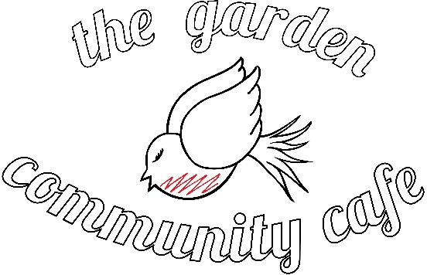

External Catering Menu

Menu 1 - £2 a Head
A mixed platter of freshly prepared sandwiches filled with meats and cheeses and served with salad.

Menu 2 - £5 a Head
A mixed platter of freshly prepared sandwiches and/or our signature handmade wraps served with salad. Plus a platter of handmade cakes and fresh seasonal fruits.

Menu 3 - £7 a Head
Freshly prepared sandwiches and/or wraps served with salad, handmade cakes and seasonal fruits. Plus a selection of hot and cold finger foods. For example, samosas, spring rolls, chicken bites and sausage rolls.

Menu 4 - £10 a Head – Everything you need for your event!
Freshly prepared sandwiches and/or wraps served with salad, handmade cakes and fruit platter, hot and cold finger foods. Plus crudités and crisps served with a selection of dips. Soft drinks and juices or hot beverages. Plus disposable cups, plates, cutlery and serviettes. We also have an urn available to loan on request.

To make an order or enquiry please contact cafe@ascension.org.uk or 020 7511 1755. Please provide at least one weeks’ notice or we may not be able to fulfil your request. Minimum order of 10 people. Delivery not currently available.

